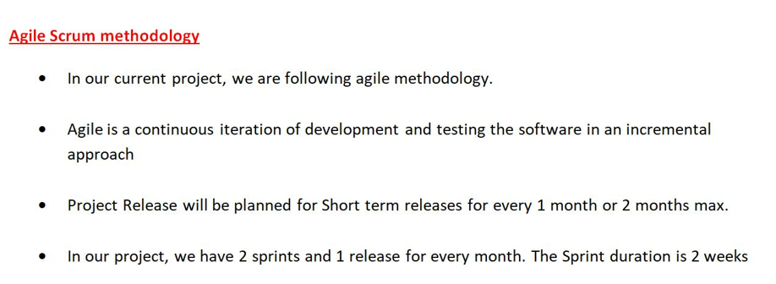

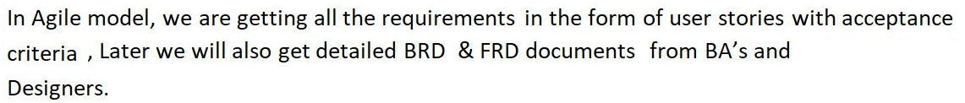

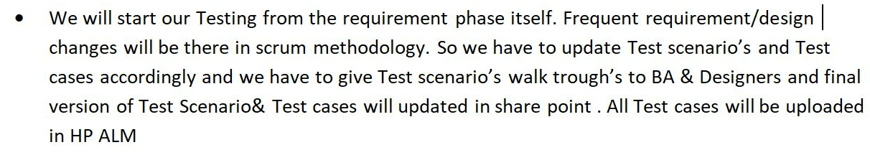

**We have attended various agile ceremonies as**

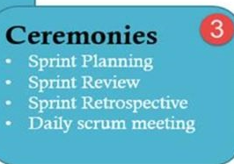

**Coming to**

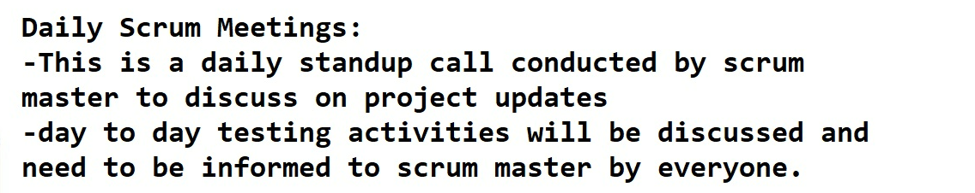

**Coming to**

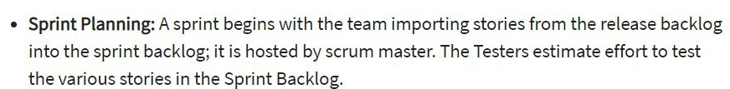

**Coming to Sprint review meetings**, internal and external reviews are performed whatever sprint activities and Test deliverables doing by team

**Coming to**

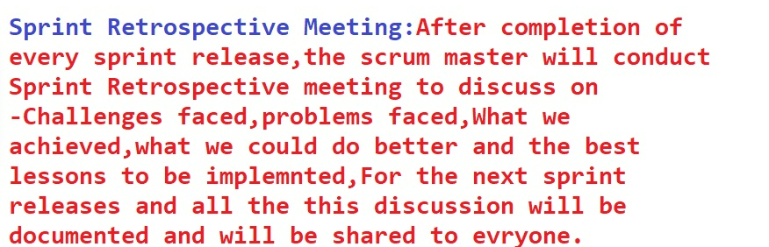

**The main artifacts in agile is Product backlog items, sprint back log items and burn down charts**

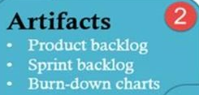

**Coming to**

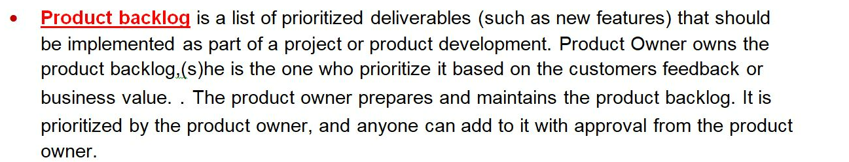

**Coming to**

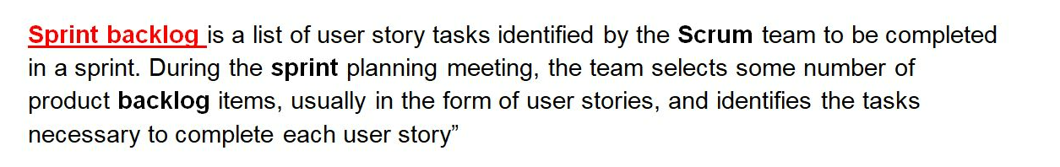

**Coming to Burn down or Burn up charts**

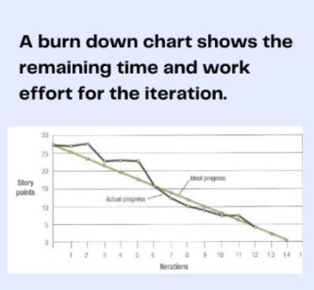 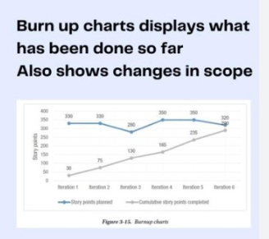

**The main roles in agile process are Product Owner , Scrum Master and Team**

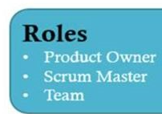

**Coming to other activities like**

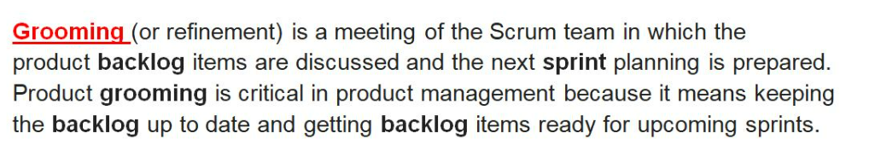

**Coming to**

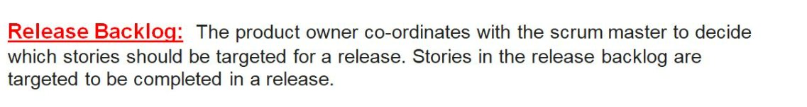

**Coming to**

